**Images provided via Jordan’s MacBook, your screen may look different!!**

1. To control Misty from anywhere in the world, download VNCViewer for your computer. <https://www.realvnc.com/en/connect/download/viewer/>
2. Sign into VNCViewer using the following username and password (images 1 & 2). The login button should be at the top right-hand corner of the VNCViewer app:
   1. Username: [jlmill41@asu.edu](mailto:jlmill41@asu.edu)
   2. Password: ASUMisty
3. From here, VNCViewer will send Jordan an email asking for she authorizes the login. Wait for her to approve the email, once approved your screen should load (image 3).
4. Navigate to the “**Address Book**” and click on it (image 4). This should be located in the top left-hand corner of the VNCViewer app.
5. Click “**raspberrypi**” (image 4), it should be the first image on the screen.
6. It will prompt you for a username and password
   1. Username: pi
   2. Password: raspberry
7. Once connected, you should see a white screen with a blue/grey box. (image 5)
8. Click “**Start Scan**” to locate the Misty in Jordan’s apt. (image 5). The scan takes ~15 seconds to complete.
9. Once the scan results are completed, click the box with an **IP address** to connect to Misty (image 6)
10. Once connected to Misty, a graphical interface will pop up. (image 7)
11. Control Misty by clicking on the **Preset Actions**, **Look** buttons to move her head, or typing what you want her to say in the white box!
12. Have fun! Beware, there may be a delay in you pressing buttons and Misty reacting! It should only be a few seconds though.

Step 2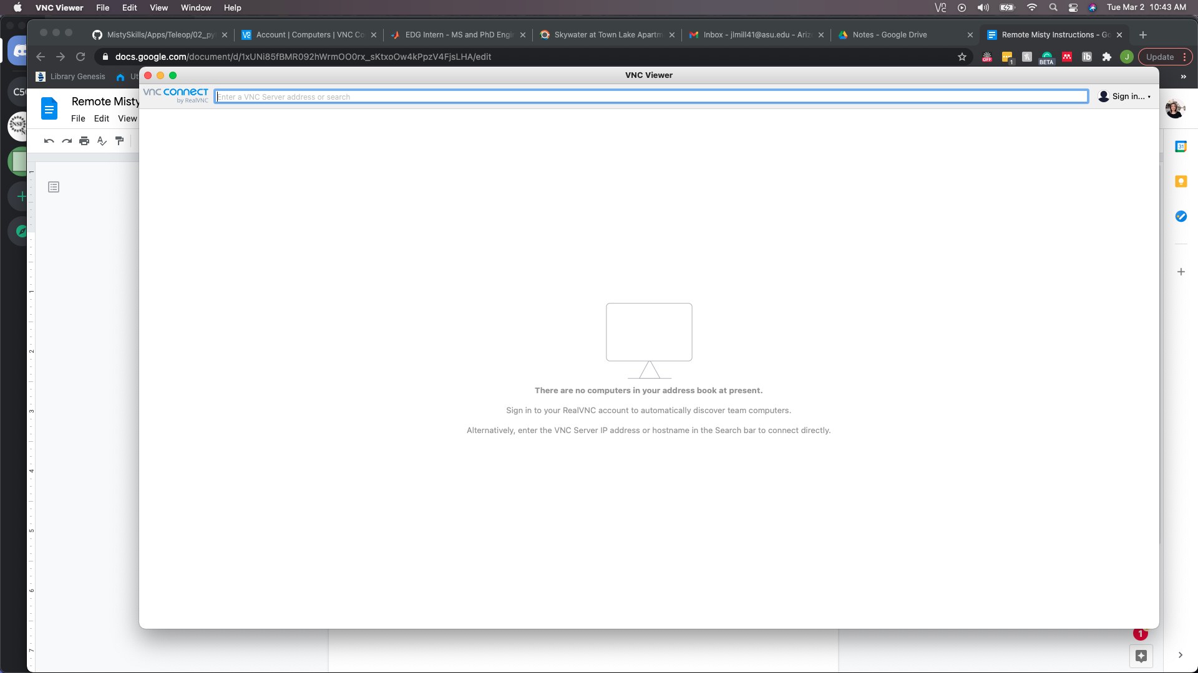

Step 2 Continued 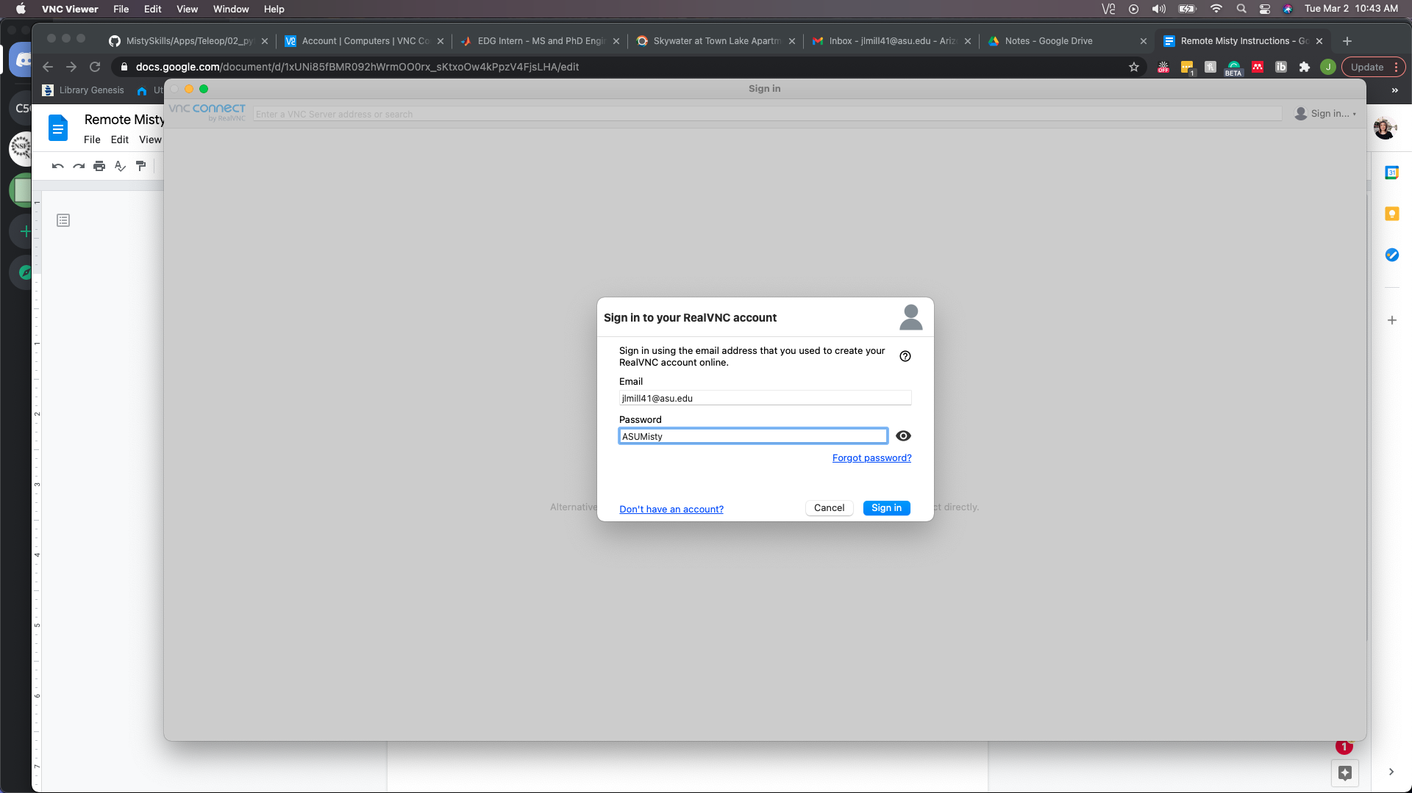

Step 3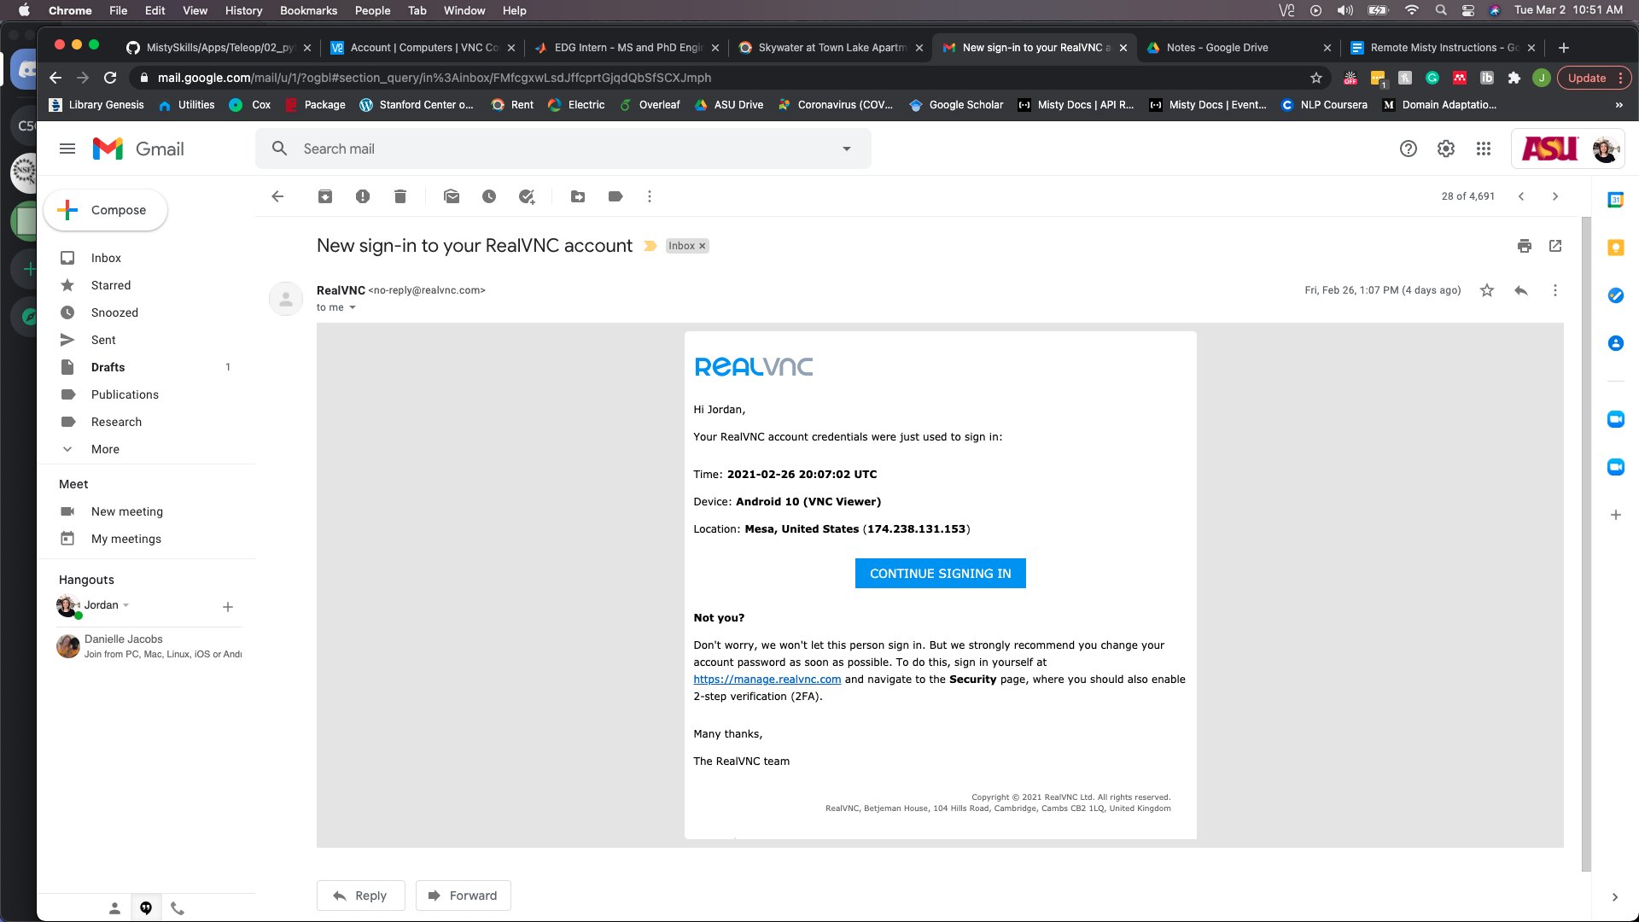

Step 4 & 5 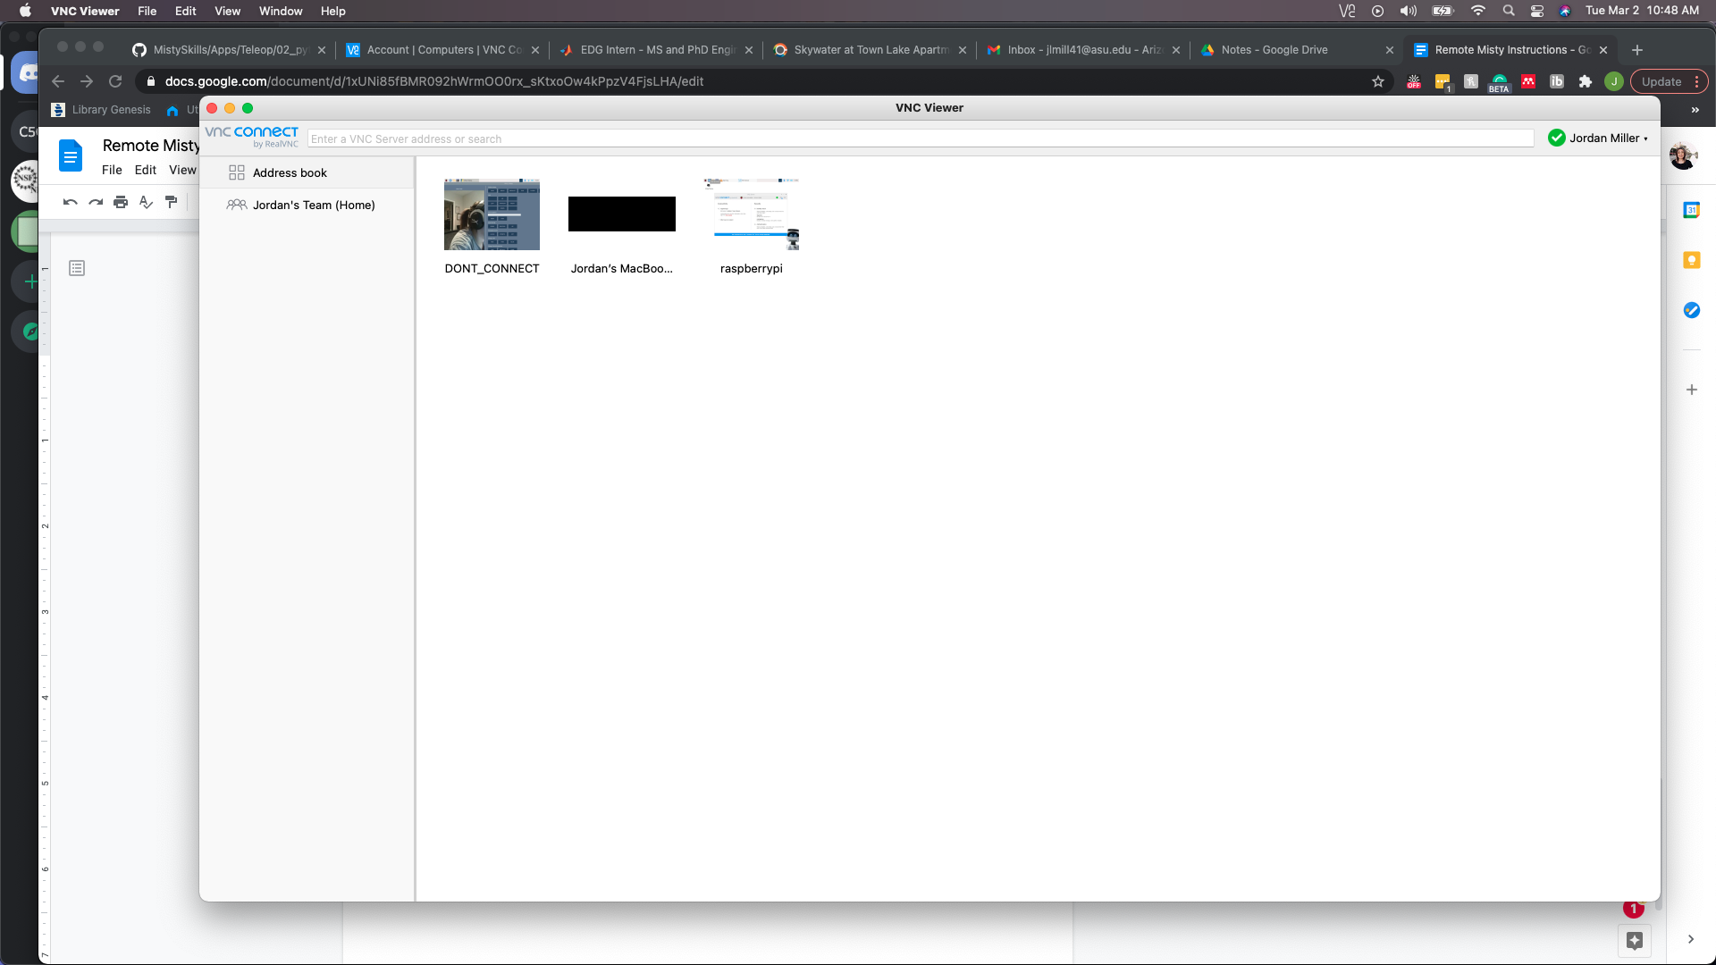

Step 7 & 8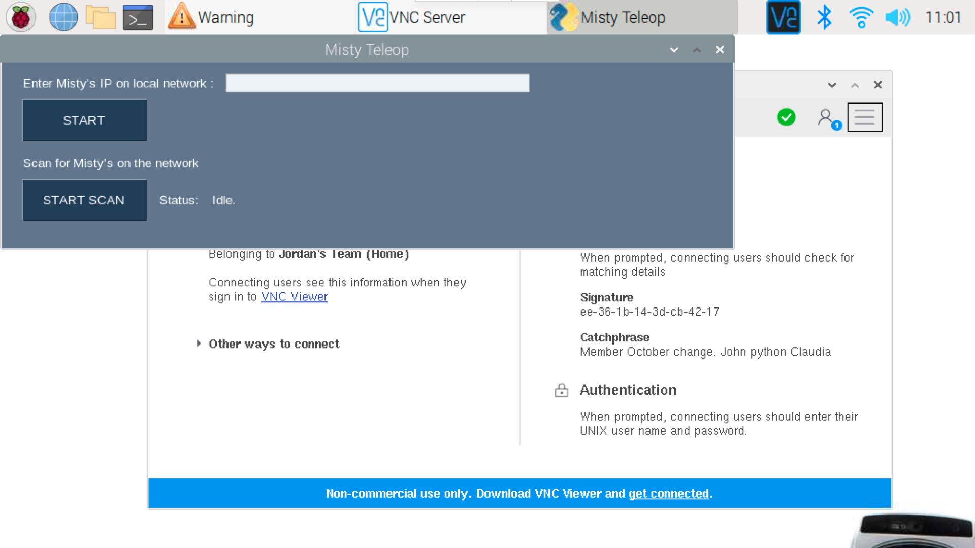

Step 9

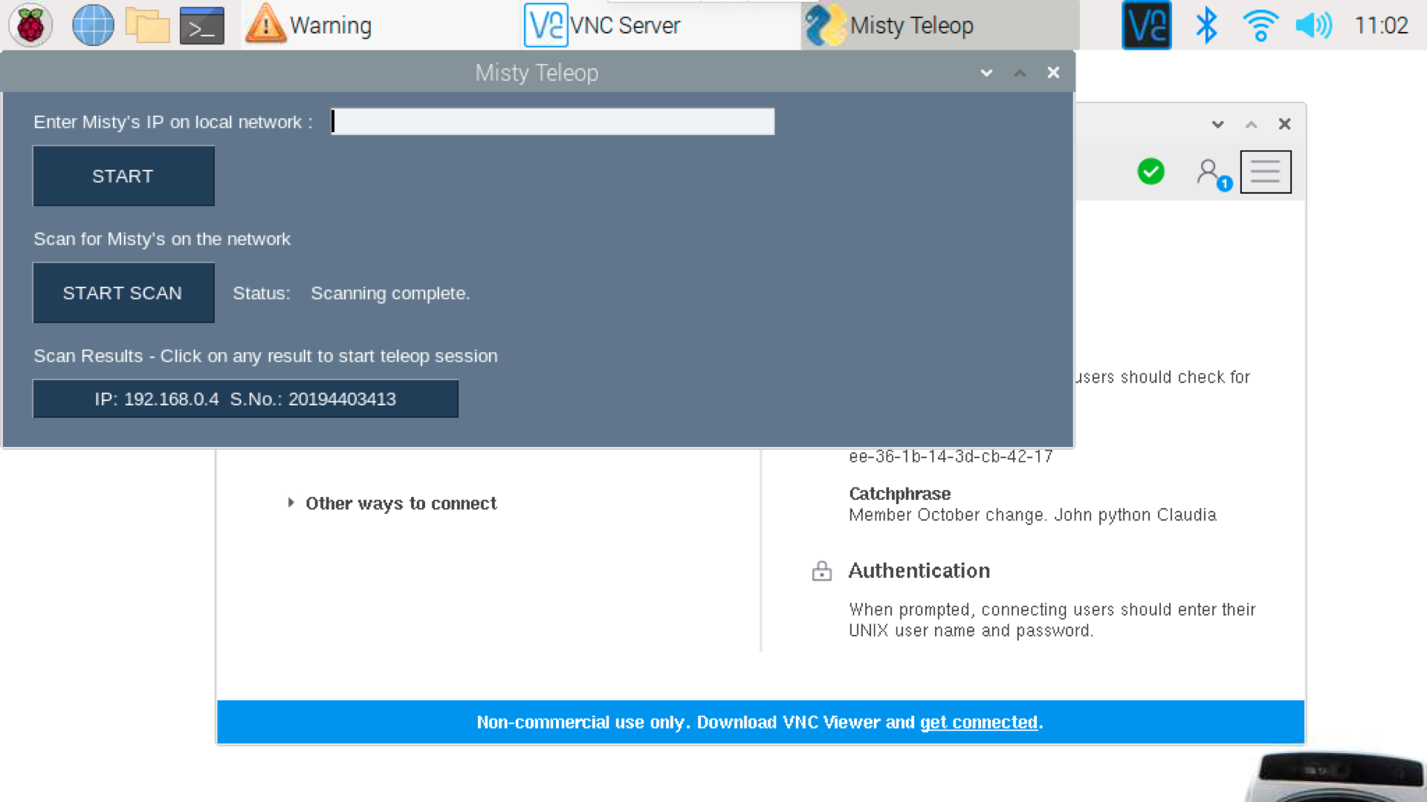

Step 10

